General INformation
Please complete this report for all Major IT projects and submit it to changemanagement@nd.gov. See additional instructions throughout and at the end of this template.
Project Name: Add text here.
Agency Name: Add text here.
Project Sponsor: Add text here.
Project Manager: Add text here.
Project Change Practitioner: Add text here.
Project:
Purpose:
People:
Particulars:

strategy decision
Change Management Risk Profile:
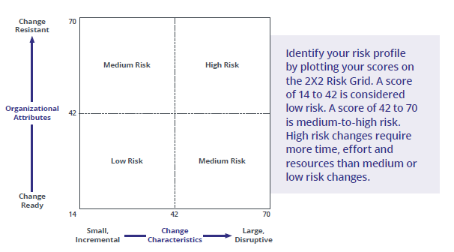
Note: The above image can be replaced with a snapshot of your project’s Risk Profile.

Chosen Strategy/Approach for Change Management:
State your chosen strategy or approach. Possible options are provided below, as well as scaling guidance that can be helpful in making your decision.
Ex. ADKAR Blueprint + ADKAR Blueprint by Group

Possible Strategies
- ADKAR Blueprint
- +ADKAR Blueprint by Group
- +Core Plans
- +Extend Plans
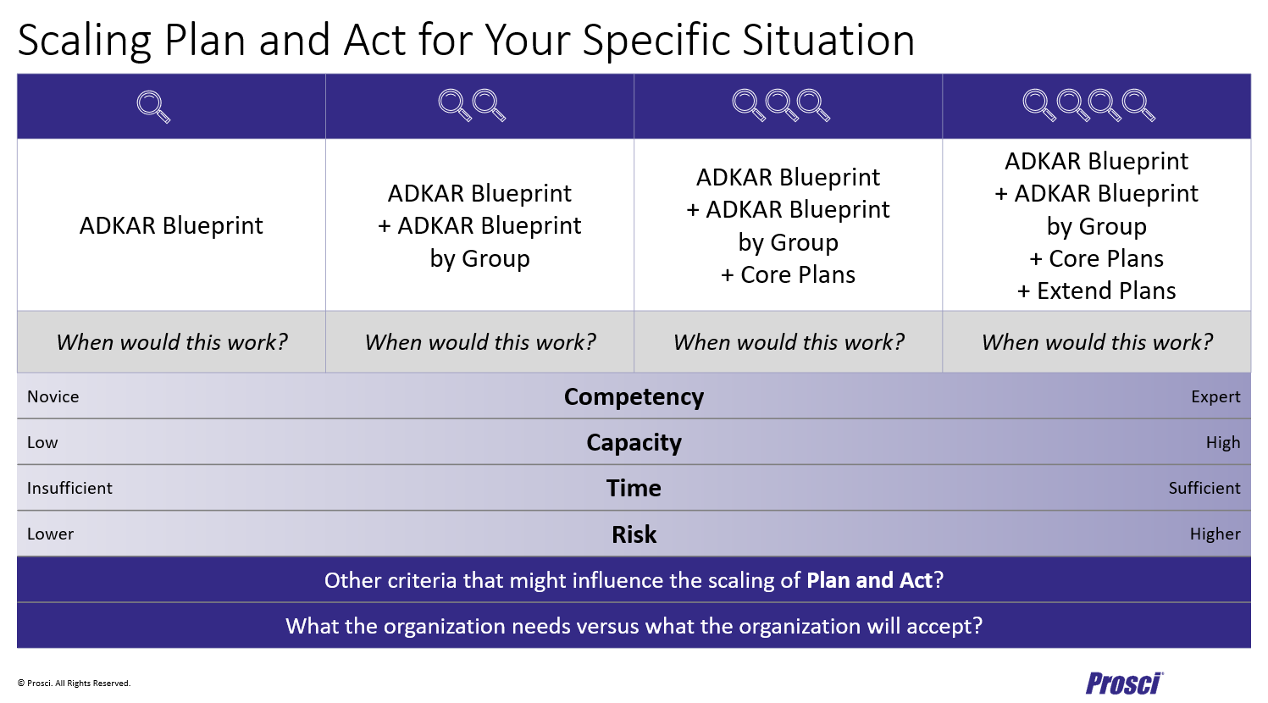
Notes:
Add text here, if necessary.

metrics – organizational readiness for change (PCT)
Provide historical PCT scores for the project, aligned with project management quarterly reporting. (Use color scheme.)
Please include a copy of the project management post-implementation and/or closeout report when filing this report.
Go-Live Date:
When is the project expected to end?
When is the transition period expected to end? (i.e. when all impacted groups are fully through ADKAR and the change is fully operationalized)
 | YYYY | YYYY | YYYY | YYYY | YYYY | YYYY | YYYY | YYYY | YYYY | YYYY | YYYY | YYYY
 | Q# | Q# | Q# | Q# | Q# | Q# | Q# | Q# | Q# | Q# | Q# | Q#
Success | 25
Leadership / Sponsorship | 25
Project Management | 25
Change Management | 25
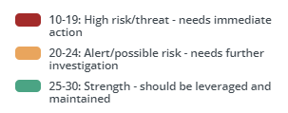

metrics – change management performance (Progress assessments)
Provide historical Performance Reporting for each relevant plan (examples shown below). Timing of the change management performance reporting should typically be aligned with the timing of project management quarterly reporting.
Please include a copy of the project management post-implementation and/or closeout report when filing this report.
Possible values: No progress, Well Behind Target, Behind Target, On Target, Ahead of Target
 | YYYY | YYYY | YYYY | YYYY | YYYY | YYYY | YYYY | YYYY | YYYY | YYYY | YYYY | YYYY
 | Q# | Q# | Q# | Q# | Q# | Q# | Q# | Q# | Q# | Q# | Q# | Q#
ADKAR Blueprint (Overall) | No Progress | Well Behind Target | Behind Target | On Target | Ahead of Target
Sponsor Plan
People Manager Plan
Communications Plan
Training Plan
Other Plan(s)

quality metrics
The overall effectiveness of change management for the project should be assessed using Prosci’s 12 Measures for Effectiveness. Each question is worth a total of 4 points. An Excel template is available to assist in calculating the effectiveness rating.
Overall Effectiveness of Change Management:
- Poor (1 point)
- Fair (2 points)
- Good (3 points)
- Excellent (4 points)
 | Evaluation | Score
Managers effectively coached employees | Excellent | 4
Leaders effectively manager resistance | Good | 3
Leaders fulfilled their roles throughout the change | Good | 3
Change activities were customized to fit the change | Fair | 2
CM Team had necessary training and expertise | Good | 3
We applied a structured change management process | Good | 3
We effectively reinforced the change | Good | 3
We had sufficient resources to implement change management | Fair | 2
We integrated CM activities into the project plan | Good | 3
We measure compliance and overall performance to objectives | Good | 3
We provided the necessary technical training to employees | Excellent | 4
We implemented an effective communication plan | Good | 3
Rating of Overall Effectiveness: | Good | 3
The average effectiveness rating rounds up at .5 and above.

Notes:
Add text here, if necessary.

Change Management Issues Identified After Go-Live | ADKAR Element

Notes:

LESSONS LEARNED (Related to Change Management)

What Went Wrong? or What Went Right? | Lesson Learned
For the Lesson Learned… What behavior or action would have prevented or improved things? What behavior or action should be repeated on future projects to promote success?

success stories (Related to change management)
How Business Problems/Needs were Resolved or Avoided with Change Management:
Add text here.

Other Ways in Which Change Management was Beneficial to the Change and/or the Organization:
Add text here.

evaluating success and outcomes
Who is responsible for final evaluation of the success of meeting the desired outcomes, and when?
Refer to project management post-implementation or closeout reports for:
- The analysis of how well business objectives were met, and
- The evaluation of how successful the project and solution were.

How well did Change Management efforts close the gap between the people and technical sides of change?
For each category, the Rating is the rating for that category (scale from 1-3 with 3 being “Excellent”).
Technical Side | People Side | Rating | Comments
Requirements | Results |  | The gap between… meeting requirements and producing results.
Outputs | Outcomes |  | …producing outputs and delivering outcomes.
Specifications | Sustainment |  | …meeting specifications and sustaining the change.
Installation | Realization |  | …installing a change and realizing the benefits of the change.
[Other]

When complete, delete all the blue instructions – here and in the document.
Additional Instructions:
- This report should be completed for all Major IT projects when the Project Manager completes the Post-Implementation Report and updated when the Project Manager completes the Closeout Report.
- This report should be sent to changemanagement@nd.gov.
- Include a copy of the project management post-implementation and/or closeout report when submitting this report.
- If you have any questions about writing or delivering this report, please contact a change management trainer or email changemanagement@nd.gov for assistance.

Attachment A: Project management report
For Major IT projects, please include a copy of the project management post-implementation and/or closeout report when submitting this change management report to changemanagement@nd.gov.
If using this report template for other types of projects that don’t require use of the PMO’s project management post-implement or closeout report templates, you may find it useful to complete the below sections in this attachment for proper evaluation of the project.
Business Objective | Measurement Description | Met/ Not Met | Measurement Outcome

Category | Overall Rating | Notes
Success of the Project
Success of the Solution
For each category, the Overall Rating is the average of the rating provided on the completed survey forms for that category (scale from 1-3 with 3 being “Excellent”).

